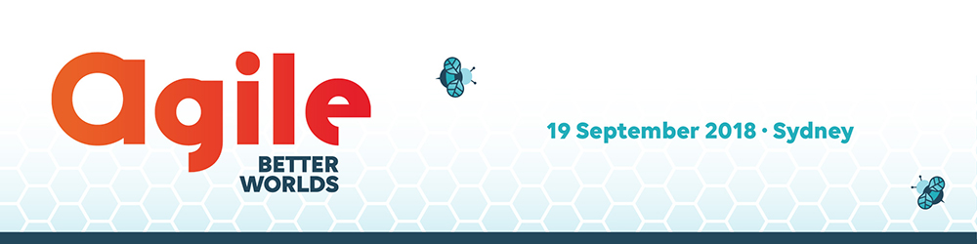
[Date]
Dear <First name of Employer>,
I am eager to attend the Better Worlds 2018 Conference on Wednesday 19 September 2018 in Sydney.
The Conference will present the latest thinking and case studies of how better ways of working are bringing value to complex organisations. International speaker Stephan Dyckerhoff will share how Buurtzorg has turned healthcare on its head by championing autonomy and self-managing teams. Local thought leaders from ABS, Adaptive Cultures, CHOICE, Data61, SBS, Transport for NSW and more will share stories on enabling cultural evolution and reducing waste to deliver products and services to benefit both our organisation and the broader community.
Better Worlds 2018 is presented by AgileAus and will attract fellow members of the agilist community, offering invaluable opportunities for networking and professional development.

I would like to attend Better Worlds 2018 to:
- Gain the tools to create a measurable shift in our team’s mindset.
- Become better equipped to respond to change and uncertainty.
- Discover how to embrace experimentation and solve problems collaboratively without depleting our workplace’s resources.
- Build the value of our organisation while maintaining, at our core, a mission of positive social change.
- Hear from peers about better ways of working to lead service delivery.
- Accelerate our Agile transformation!
I would be happy to report back to my colleagues on my learnings from the Conference, provide briefs as required on the topics covered and share presentations from the speakers.
The cost to attend Better Worlds 2018 Conference is: <insert relevant cost>:
Cost: Enterprise $550; Government, non-profits, for-purpose and startups orgs: $275
Full details are available betterworlds.com.au.
There is also an option to register a group of delegates from our organisation, which would entitle us to a rate of $199 per person if we bring a group of 5 or more.
Travel and accommodation costs for this Conference are estimated at <insert estimate>.
I believe my attendance at Better Worlds 2018 will be enormously beneficial for professional development, networking, and enhancing a range of skills, from teamwork to communication.
Yours sincerely,
<insert name>

